A refeição contém ou pode conter as seguintes substâncias ou produtos e seus derivados:
1- Glúten; 2- Crustáceos/Marisco; 3-Ovos; 4-Peixe e produtos à base de peixe; 5- Amendoins; 6- Soja; 7- Leite/Lactose; 8- Frutos de Casca Rija; 9- Aipo; 10- Mostarda; 11- Sementes de sésamo; 12- Dióxido de Enxofre; 13- Tremoços; 14- Moluscos

Espetada Primaveril
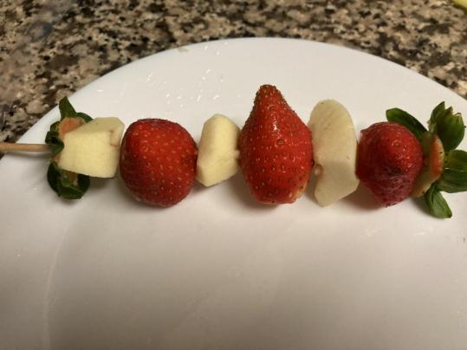
Método de Confeção: cru
Ingredientes | Capitação Bruta (g/ml) | Parte Edível (%) | Peso Edível (g/ml)
Maçã | 45 | 80 | 36
Morangos | 45 | 96 | 43,2

Preparar e desinfetar as frutas. Espetar as diferentes frutas em paus de madeira e servir.
Modo de Preparação

Observações
As frutas são essencialmente da época e frescas e provenientes de uma agricultura sustentável.

Ingredientes* | Energia (Kcal) | Água (g) | Proteína (g) | Gordura total (g) | Total HC disponíveis (g) | Total HC expresso em monossacáridos (g) | Mono + dissacarídeos (g) | Ácidos orgânicos (g) | Álcool (g) | Amido (g) | Oligossacáridos (g) | Fibra Alimentar (g) | Ácidos gordos saturados (g) | Ácidos gordos monoinsaturados (g) | Ácidos gordos polinsaturados (g) | Ácidos gordos trans (g) | Ácido linoleico (g) | Colestrol (mg) | Vit. A total (µg) | Caroteno (µg) | Vit. D (µg) | α-tocoferol (mg) | tiamina (mg) | Riboflavina (mg) | Equivalentes de Niacina (mg) | Niacina (mg) | Triptofano/60 (mg) | Vit. B6 (mg) | Vit.B 12 (µg) | Vit.C (mg) | Folatos (µg) | Cinza (g) | Na (mg) | K (mg) | Ca (mg) | P (mg) | Mg (mg) | Fe (mg) | Zn (mg)
Melão | 27 | 91,8 | 0,6 | 0,3 | 5,7 | 5,8 | 5,7 | 0 | 0 | 0 | 0 | 0,9 | 0,1 | 0,1 | 0,1 | 0 | 0,1 | 0 | 167 | 1000 | 0 | 0,10 | 0,020 | 0,02 | 0,40 | 0 | 0,90 | 0 | 0 | 30 | 3 | 0,68 | 12 | 227 | 10 | 12 | 19 | 0,5 | 0,8
Maçã | 54 | 83,8 | 0,2 | 0,5 | 12,7 | 12,8 | 12,7 | 12,7 | 0,20 | 0 | 0 | 0 | 1,9 | 0,1 | 0 | 0,2 | 0 | 0,1 | 4 | 25 | 0 | 0,27 | 0,020 | 0,030 | 0,20 | 0,10 | 0,10 | 0,040 | 0 | 5 | 5 | 0,32 | 6,0 | 116 | 5,0 | 6,0 | 5,0 | 0,20 | 0
Laranja | 48 | 0,2 | 0 | 0 | 0,1 | 0 | 0 | 9,1 | 8,9 | 0 | 0 | 0 | 1,8 | 1,1 | 0 | 86,3 | 0,7 | 0 | 20 | 120 | 0 | 0,24 | 0,09 | 0,05 | 0,7 | 0,8 | 0,1 | 0,1 | 0 | 57 | 31 | 0,42 | 4 | 160 | 35 | 19 | 11 | 0,2 | 0,1
Morango | 29 | 90,1 | 0,6 | 0,4 | 5,3 | 5,4 | 5,3 | 0,77 | 0 | 0 | 0 | 2 | 0 | 0 | 0,3 | 0,2 | 0 | 0.1 | 4 | 26 | 00 | 0,20 | 0,030 | 0,060 | 0,80 | 0,60 | 0,20 | 0,050 | 0 | 47 | 47 | 0,58 | 2 | 138 | 25 | 26 | 10 | 0,8 | 0,1
Total | 158 | 265,9 | 1,4 | 1,2 | 23,8 | 24 | 23,7 | 22,57 | 9,1 | 0 | 0 | 2,9 | 3,8 | 1,3 | 0,4 | 86,7 | 0,8 | 0,1 | 195 | 1171 | 0 | 0,81 | 0,16 | 0,16 | 2,1 | 1,5 | 1,3 | 0,19 | 0 | 139 | 86 | 2 | 24 | 641 | 75 | 63 | 45 | 1,7 | 1
*por 100 gr

